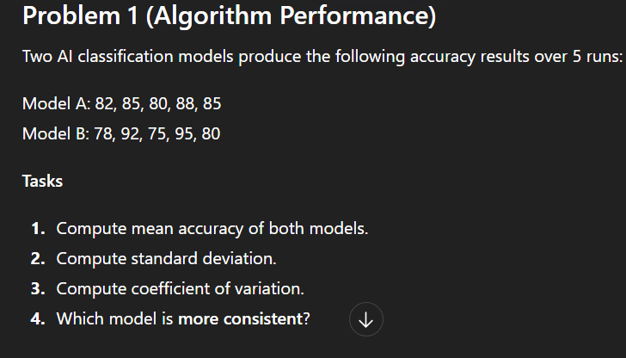

Problem 2 (Sensor Data Consistency)
Two sensors measure temperature (°C):
Sensor A:
20, 21, 19, 22, 18, 20
Sensor B:
20, 20, 21, 19, 20, 20
Tasks
- Calculate mean temperature.
- Calculate variance and standard deviation.
- Compute coefficient of variation.
- Identify which sensor is more reliable/consistent

Q3:The following table shows training accuracy (%) of an AI model across different experiment runs.

Accuracy (%) | Frequency
60–65 | 4
65–70 | 6
70–75 | 10
75–80 | 8
80–85 | 2
Tasks
- Find the mean accuracy.
- Calculate the standard deviation for the grouped data.
- Compute the coefficient of variation.
- Comment on the consistency of the model’s accuracy.

